08/07/2017

Name: Virti Bipin Sanghavi ID: 1001504428

Name: Dhinesh Kumar Sivakumaran ID: 1001393555

**The following relations have been inserted into the office Database which are demonstrated as follows:**

**1)employee**

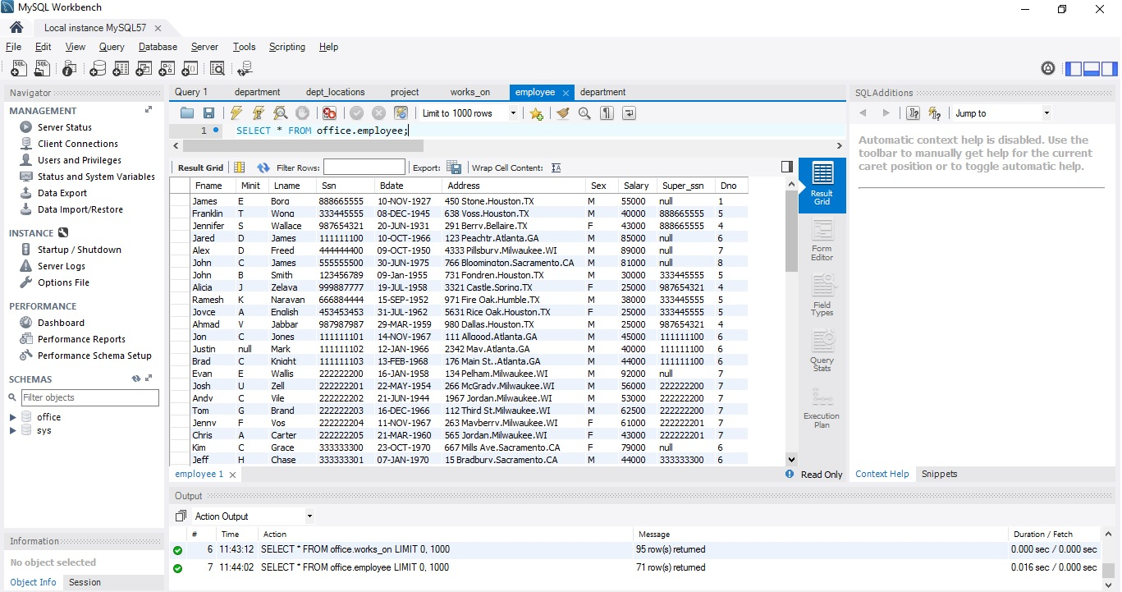

**2)department**

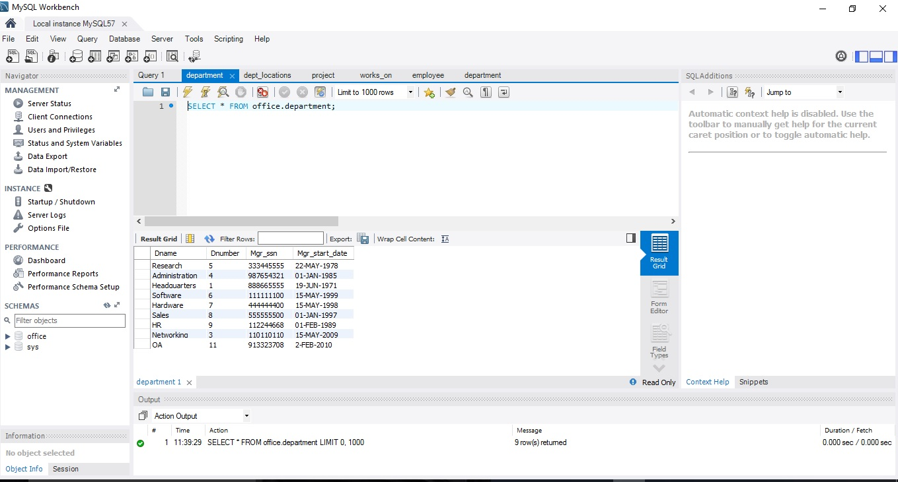

**3)works_on**

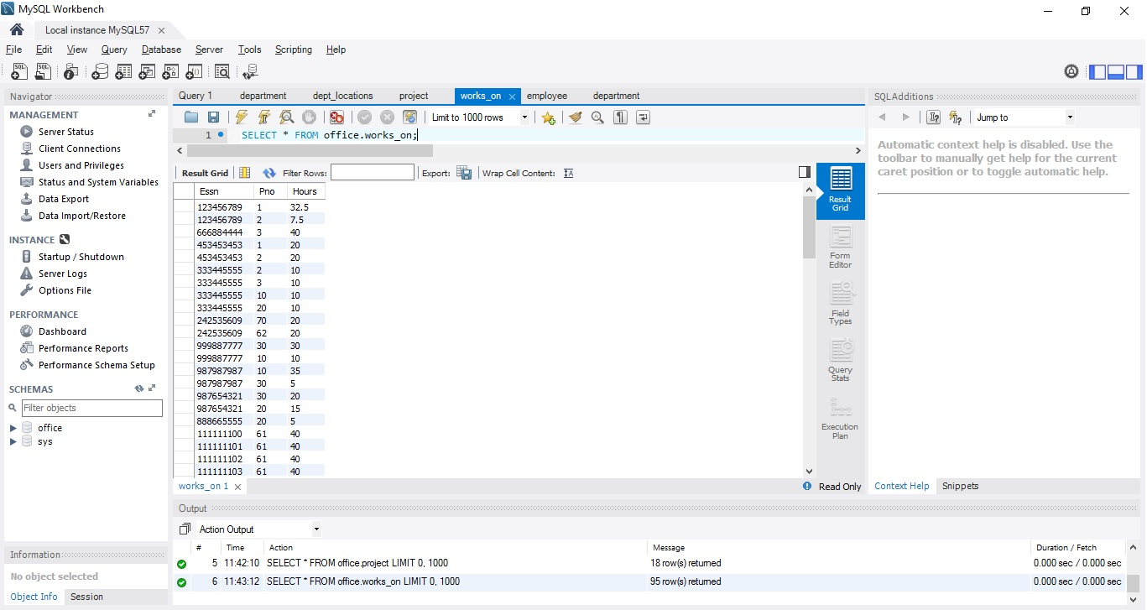

**4) dept_locations**

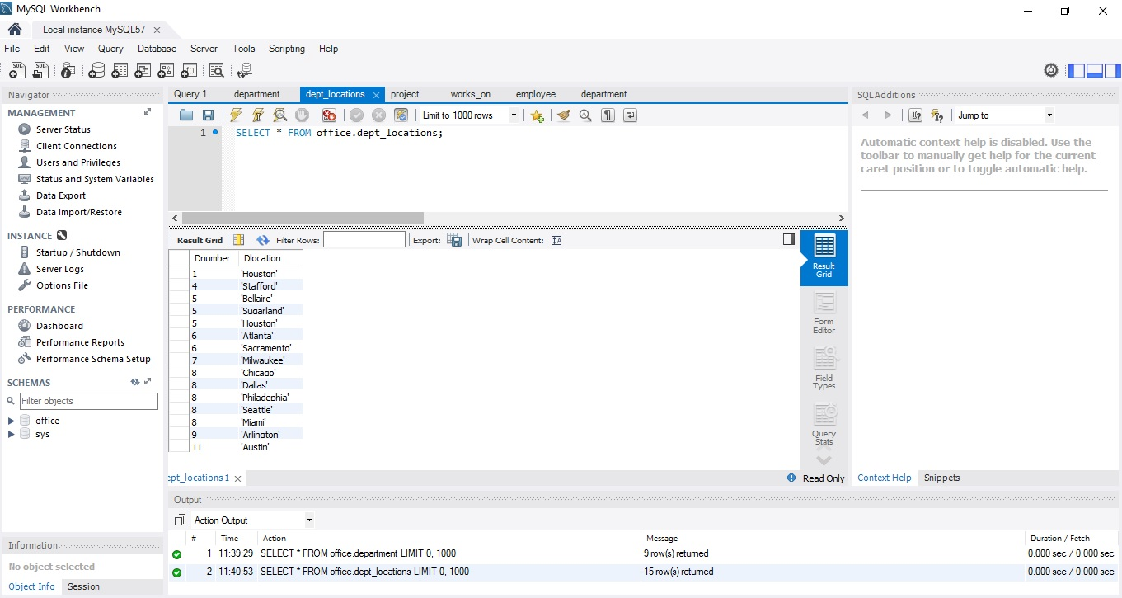

**5) project**

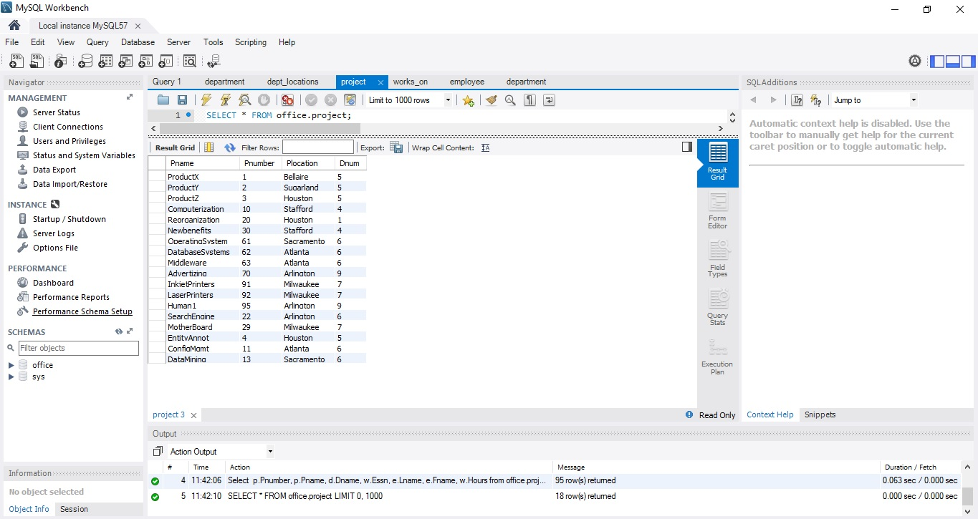

**Installation of MongoDB**

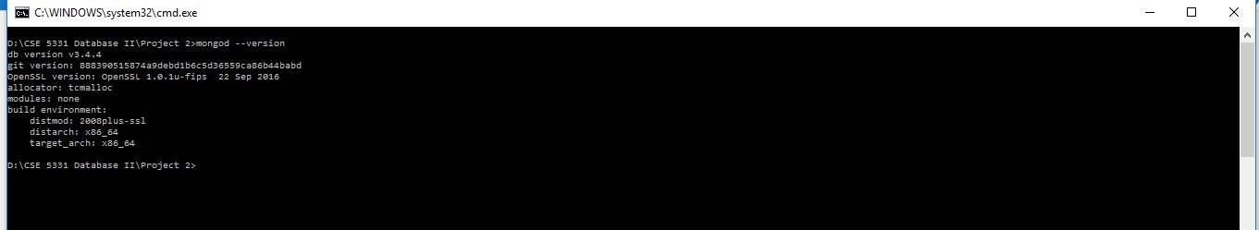

**MongoDB Server Started**

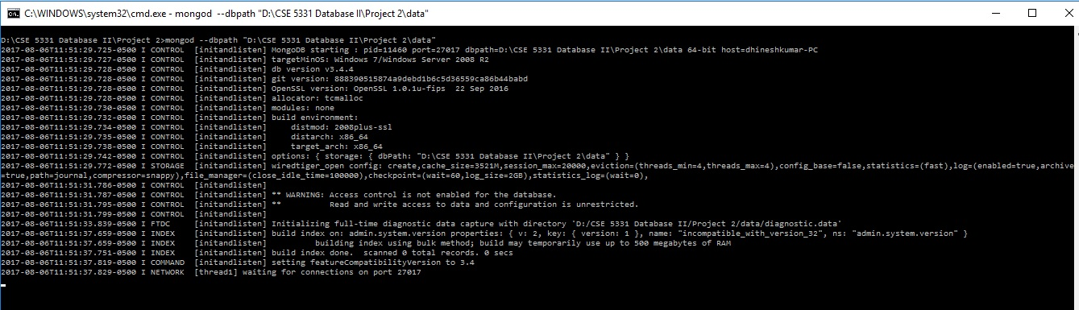

**Simple Document of MongoDB creation**

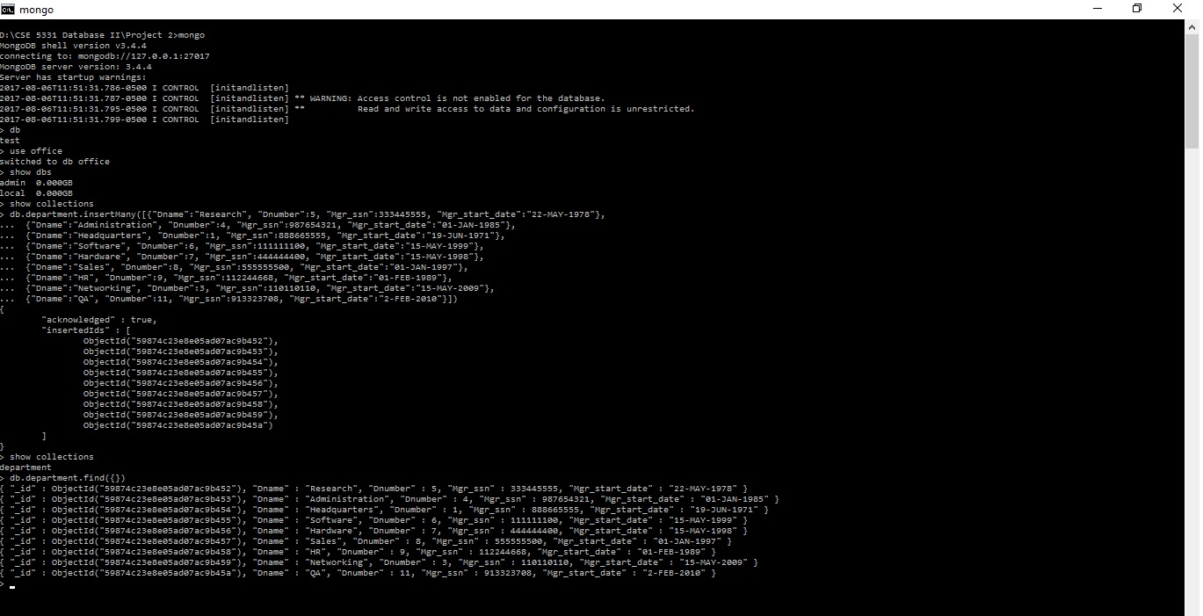

**How do you convert Relational Data into Mongodb?**

Pname, Pnumber attributes from the project and Dname attribute from the Department needs to be common for a particular group of project which is managed by a specific department.

The ESSn, Fname ,Lname and working hours of the employee attributes corresponding to a particular project needs to be clubbed into an array for a specific department and the project in which an employee is working by grouping the attributes by Project Number(Pnumber).

**Result for the Project Data:**

1. The PROJECT document will include the following data: Pnumber, Pname, Dname (of the controlling department), plus a list of the employees that work on the project {employees: Lname, Fname, Hours}.

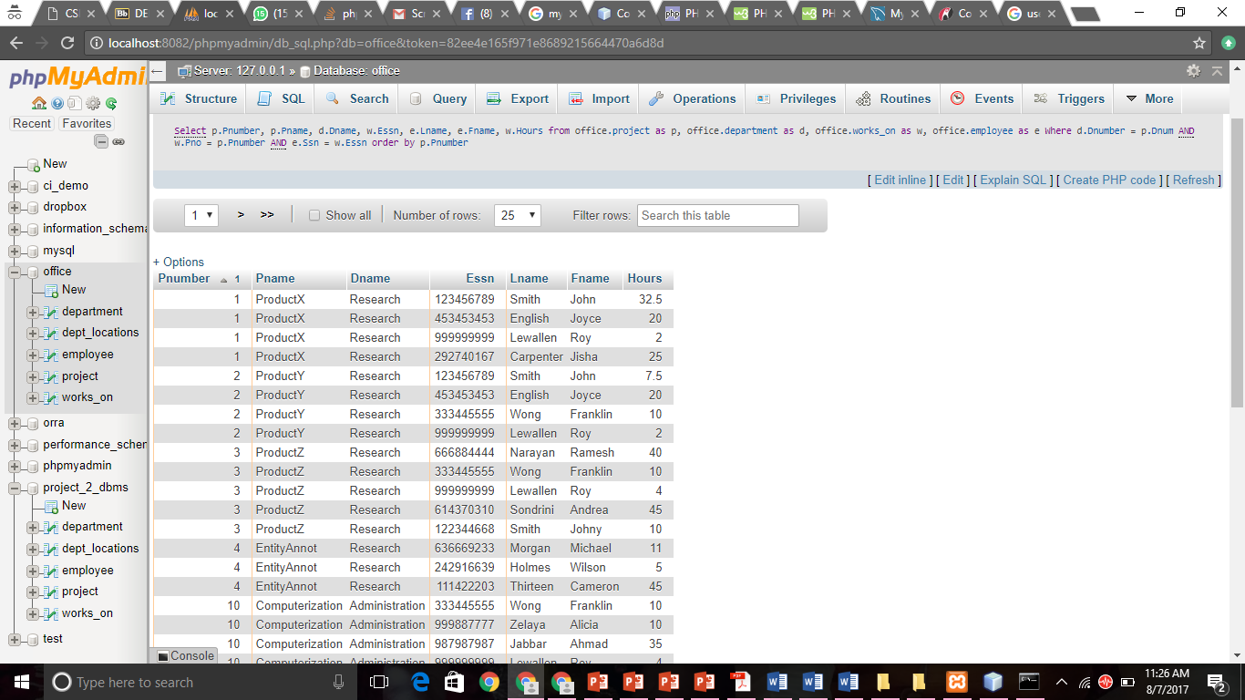

**Result for the Department Data:**

1. The DEPARTMENT document will include the following data: Dname, the department manager’s Lname, and a list of the locations of the department {locations: Dlocation}.

**Here we have been using grouping by attribute and group by Department name(Dname).**

Here, the department name stays constant, we make an array of the list of Last names of the manager of the department and the location he is working on.

